27.50: a) Field current 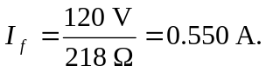
b) Rotor current
c)
d)
e)
f) Power input = (120 V) (4.82 A) = 578 W.
g) Efficiency = 